# SOFTWARE TESTING AND MAINTENANCE

# Project

# Finn Hawkes

# 91050039

## Overview:

For this project I will run over the supplied code for the game provided by the stake holder and then from that break the code down to run tests on it and see how the game functions and if it is fully bug checked and run multiple different tests to check to see how the code works under all instances and circumstances.  
I will have the code on GitHub to see the project   
The GitHub link is: <https://github.com/boghopper2/BowlingGame>

## Test Plan:

For the code once I can confirm that it works in the correct method, I’ll be running some tests on the project,   
the tests I intend to run will be in relation to how the game is run and what rolls they make and what pins they hit to confirm the final score is correct when they finish the game to ensure that the scoring maths are correct.

The tests that I will be running are:

* Hitting only one pin on every throw in a game
* Hitting no pins for an entire game
* Checking to see if it is possible to complete the perfect game.
* Checking to see if getting a spare gives the correct score.
* Checking to see the score is correct making different bowls.
* Checking to see what the score is once hitting one strike.
* Checking to see how it goes while making two strikes.

These tests will be made in the unit test case to ensure that the expected outcome comes true after running the code.

**For the first test** *hitting only one pin on every throw in a game* because during a game there are 20 throws of the ball and the idea is to only hit one pin each throw at the end of the game the idea is to have a final score of 20.

**For the second test** of *hitting no pins for an entire game* at the end of the 20 throws and all being misses the final score of the game will be zero

**For the third test** *checking to see if it is possible to score a perfect game*, this test is a good one as there are extra factors when it comes to getting multiple strikes in a row as there is an additional multiplier, if you are to roll a strike each time then it should be a game of 300

**The fourth test** is testing to see *the outcome from scoring a spare.* The expected outcome from the spare run will be 24 after throwing one spare, and then after rolling an additional throw of a 7 to see if the correct multiplier is in effect.

**The fifth test** is to *see if rolling different points adds up to the correct amount.* This is to test if, when throwing multiple different rolls, the total score is correct over the period of the run.

**The sixth test** is to *check the score after only scoring one strike.* This is to ensure that, once a strike is rolled and then another is rolled right after, that the strike’s multiplier works after the roll, adding up to the correct amount.

**The final/seventh test** is to *see what the final score is after scoring two strikes* to ensure the additional multiplier as previously mentioned in the past test to see if the extra multiplier still works properly.

## Unit tests:

**Test one**:  
So for the first test of *hitting only one pin on every throw in a game* the idea is to do the 20 rolls down the lane and only hit one each time during said rolls, meaning at the end we intend on having a score of 20, we do this by making it so the test only passes if the final score is 20, if the final score isn’t 20 it means the test didn’t work and there is something wrong with the scoring variable.

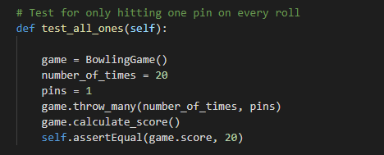

So above is the code for the test case, it runs the bowling game 20 times and each time it hits one pin, so at the end of the game it should pass the test, I expect the test will pass as the scoring function has been working correctly.

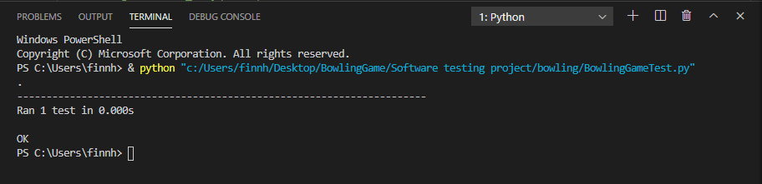

Above is the output after running the test case, the test case passed which is what I was hoping for from the test case, with this running correctly it is showing that the scoring is working correctly.

**Test two**:

The second test is hitting no pins for an entire game this will mean after the 20 throws and intentionally hitting no pins the test will only pass if the score is zero, if the score is anything else the test will fail, with the test of only hitting one pin worked correctly I believe this test will pass.

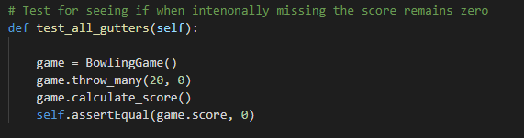So as the test goes it will throw the ball 20 times and each time it will hit zero pins, then after the 20 throws of no hits it will score nothing and only if the test results with a score of zero will the test pass.

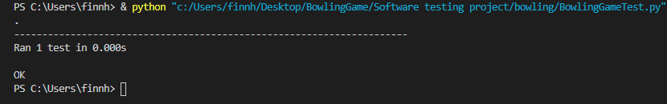After running the test the prediction of it passing came true and the test ran and passed meaning that it got the score of zero which was the correct and expected outcome

**Test three**:

**Test four**:

**Test five**:

**Test six**:

**Test seven**:

## Python Doc comments:

## Summary: